CHAPTER 5

File Management System
A file is a named collection of related information that is recorded on secondary storage such as magnetic disks, magnetic tapes and optical disks. In general, a file is a sequence of bits, bytes, lines or records whose meaning is defined by the files creator and user.
The physical storage is converted into logical storage by the operating system. The logical storage unit is said to be files called records. A record is a collection of related fields.
We have three essential requirements for long-term information storage:
1. It must be possible to store a very large amount of information.
2. The information must survive the termination of the process using it.
3. Multiple processes must be able to access the information concurrently.
The usual solution to all these problems is to store information on disks and other external media
in units called files. Processes can then read them and write new ones if need be. Information
stored in files must be persistent, that is, not be affected by process creation and termination. A
file should only disappear when its owner explicitly removes it.
Files are managed by the operating system. How they are structured, named, accessed, used, protected, and implemented
File system is the part of operating system that deals with file organization
FILE NAMING:
- When a process creates a file, it gives the file a name
Rules for file naming vary from system to system, but all current operating systems allow strings of one to eight letters as legal file names. Digits and special characters are also permitted
- Many file systems support names as long as 255 characters
FILE OPERATIONS:
- Files exist to store information and allow it to be retrieved later. Different systems provide different operations to allow storage and retrieval.
- Create. The file is created with no data.
- Delete. When the file is no longer needed, it has to be deleted to free up disk space.
- Open. Before using a file, a process must open it.
- Close. When all the accesses are finished, so the file should be closed
- Read. Data are read from file
- Write. Data are written to the file, again, usually at the current position.
- Append. This call is a restricted form of write. It can only add data to the end of the file.
- Seek. For random access files, a method is needed to specify from where to take the data.
- Get attributes. Processes often need to read file attributes to do their work.
- Set attributes. Some of the attributes are user settable and can be changed after the file has been created.
- Rename. It frequently happens that a user needs to change the name of an existing file.
- Lock. Locking a file or a part of a file prevents multiple simultaneous access by different process.
File Attributes
Every file has a name and its data. In addition, all operating systems associate other information
with each file, for example, the date and time the file was created and the file's size. We call
these extra items the file's attributes although some people called them metadata
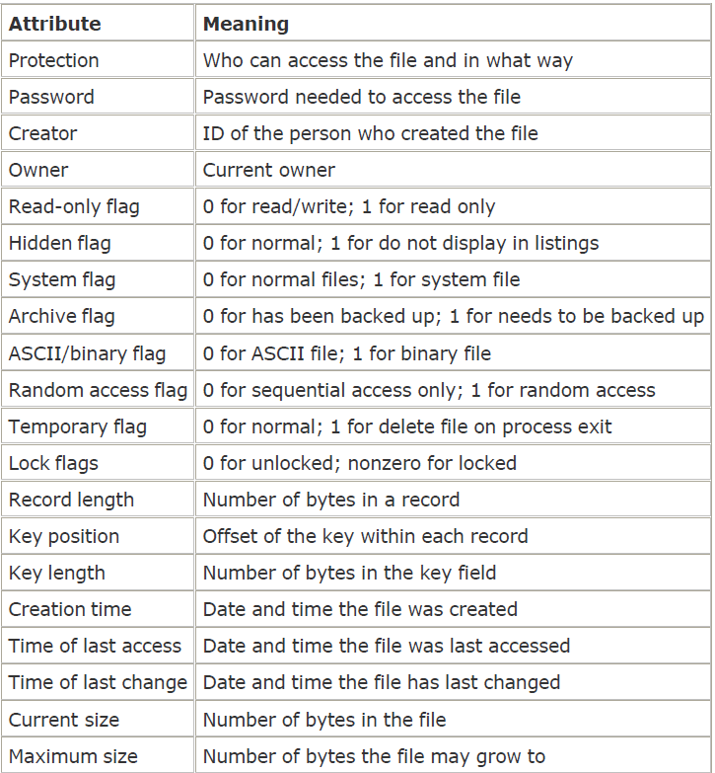
File management system (FMS) is a collection of system software programs that provides services to the users. The following are general objectives of FMS:
- To provide the IO support for multiuser
- Storages of data
- To optimize performance
Many operating systems support two-part file names, with the two parts separated by a period, as in prog.c. The part following the period is called the file extension and usually indicates something about the file, in this example that it is a C programming language source file.
Some typical file extensions.
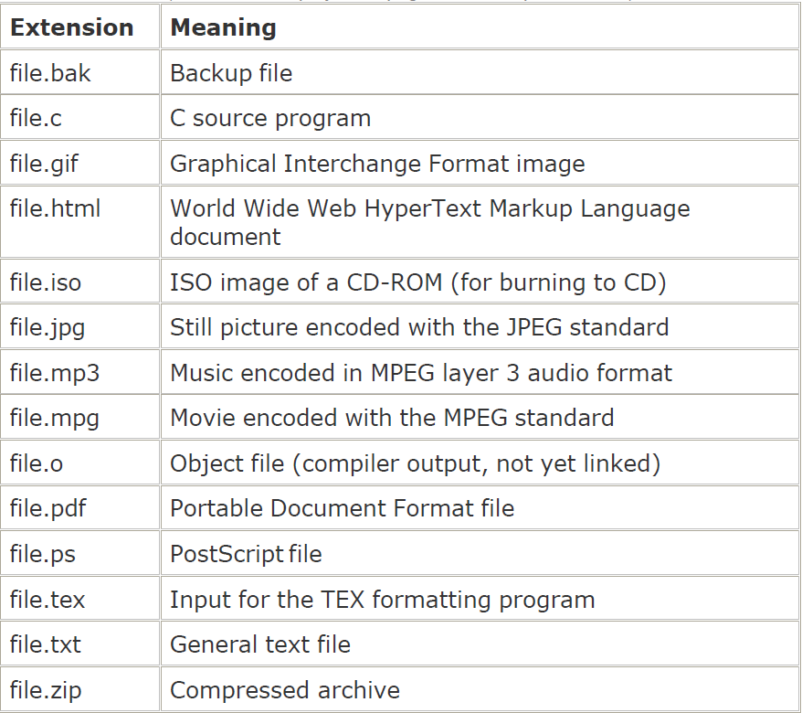

File Structure
File structure is a structure, which is according to a required format that operating system can understand.
- A file has a certain defined structure according to its type.
- A text file is a sequence of characters organized into lines.
- A source file is a sequence of procedures and functions.
- An object file is a sequence of bytes organized into blocks that are understandable by the machine.
Files can be structured in any of several ways. Three common possibilities are shown below.
a. In byte sequence
- operating system sees the file as a set of bytes.
- Unix and windows 98 use this schema.
- user can put anything in file and name it
b. In record sequence
- a file is a sequence of fixed-length records, each with some internal structure.
- Read and write operations are performed on this fixed length records.
c. In tree structure
- A file consists of a tree of records, not necessarily all the same length.
- Each file contains a key field in a fixed position in the record.
The tree is sorted based on the key field, to allow rapid searching for a particular key
Information about files are kept in the directory structure, which is maintained on the disk
File Types
File type refers to the ability of the operating system to distinguish different types of file such as regular files and directory files etc. UNIX also has character and block special files. Windows XP also uses metadata files.
A common technique for implementing file types is to include the type as part of the file name. The name is split into two parts: a name and an extension.

Regular files
- These are the files that contain user information.
- Regular files are generally either ASCII files or binary files. ASCII files consist of lines of text.
- Binary files have some internal structure known only to programs that use them. This file is just a sequence of bytes. O.S executes this file only if it has proper format.
- The great advantage of ASCII files is that they can be displayed and printed as it is, and they can be edited with any text editor.
- The user can apply various operations on such files like add, modify, delete or even remove the entire file.
Directory files
- These files contain list of file names and other information related to these files.
- Directories are system files for maintaining the structure of the file system.
Special files:
- These files are also known as device files.
- These files represent physical device like disks, terminals, printers, networks, tape drive etc.
These special files are of two types
- Character special files are related to input/output and used to model serial I/O devices such as terminals, printers, and networks. - data is handled character by character as in case of terminals or printers.
- Block special files - data is handled in blocks as in the case of disks and tapes.
File Access Mechanisms
File access mechanism refers to the manner in which the records of a file may be accessed. There are several ways to access files
Sequential access
Here process can read bytes or records in a file in order from beginning, but could not skip around and read them out of order. This access method is the most primitive one. Example: Compilers usually access files in this fashion. Sequential files were convenient when the storage medium was magnetic tape
Direct/Random access
- In disks this file access is used. This type is suitable for database systems, etc.
- It is possible to read the bytes or records of a file out of order, or to access records by key, rather than by position. Files whose bytes or records can be read in any order are called random access files.
- Random access file organization provides, accessing the records directly.
- Each record has its own address on the file with by the help of which it can be directly accessed for reading or writing.
- The records need not be in any sequence within the file and they need not be in adjacent locations on the storage medium.
Indexed sequential access
- This mechanism is built up on base of sequential access.
- An index is created for each file which contains pointers to various blocks.
- Index is searched sequentially and its pointer is used to access the file directly.
DIRECTORIES:
To keep track of files, file systems normally have directories or folders
- Single-Level Directory Systems:
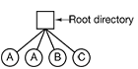
- The simplest form of directory system is having one directory containing all the files
- Advantage is simplicity and ability to locate files quickly.
Disadvantage: Different users may accidentally use the same names for their files. For example, if user A creates a file called mailbox, and then later user B also creates a file called mailbox, B's file will overwrite A's file
.b. Two-level Directory Systems
To overcome the disadvantage of single directory system, each user here are given a private directory. This design could be used, for example, on a multiuser computer or on a simple network of personal computers that shared a common file server over a local area network
when a user tries to open a file, the system knows which user it is in order to know which directory to search. As a consequence, some kind of login procedure is needed
- Here users can only access files in their own directories. However, a slight extension is to allow users to access other users’ files by providing some indication of whose file is to be opened.
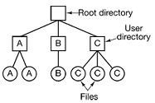
Advantage: eliminates name conflict problem in case of multiple users.
Disadvantage: Not efficient in presence of large number of files
C Hierarchical Directory Systems:
In order to manage many files, hierarchy structure i.e. tree of directories is preferred
- Here each user can have as many directories as are needed.
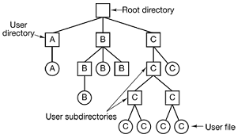
- Users can create an arbitrary number of subdirectories
- This schema acts as a powerful structuring tool for users to organize their work.

PATH NAMES
- Two different methods are commonly used for specifying or denoting the file names placed inside a directory file system
In the first method, each file is given an absolute path name consisting of the path from the root directory to the file. Ex. /usr/ast/mailbox
- Absolute path names always start at the root directory
Second way is to use relative path name.
- A user can designate one directory as the current working directory and any reference for a file means it is present within the working directory.
- But if a file has to be accessed regardless of the working directory, then absolute path name must be specified.
File System Implementation
Now it is time to turn from the user's view of the file system to the implementer's view. Users are concerned with how files are named, what operations are allowed on them, what the directory tree looks like, and similar interface issues. Implementers are interested in how files and directories are stored, how disk space is managed, and how to make everything work efficiently and reliably.

File System Layout
File systems usually are stored on disks. most disks can be divided up into partitions, with independent file systems on each partition. Sector 0 of the disk is called the MBR(Master Boot Record) and is used to boot the computer. The end of the MBR contains the
partition table. This table gives the starting and ending addresses of each partition
The first thing the MBR program does is locate the active partition, read in its first block, called the boot block, and execute it. the master boot record may sometimes be called the IPL (Initial Program Loader), Volume Boot Code, or simply masterboot.
On PC-compatible systems there can be no more than four primary partitions because there is only room for a four-element array of partition descriptors between the master boot record and the end of the first 512-byte sector. Some operating systems allow one entry in the partition table to be an extended partition which points to a linked list of logical partitions.
superblock contains all the key parameters about the file system like file system type, the number of blocks in the file system, and other key administrative Information and is read into memory when the computer is booted.
Free space mgmt block tells about free blocks in the file system
the i-nodes, an array of data structures, one per file, telling all about the file and where its blocks are located. Each file and directory has an i-node that contains access information such as file type, access permissions, owner's ID, and number of links to that file. These i-nodes also contain "addresses" for finding the location on the disk where the data for a logical block is stored.
The root directory contains the top of the file system tree. Finally, the remainder of the disk typically contains all the other directories and files.

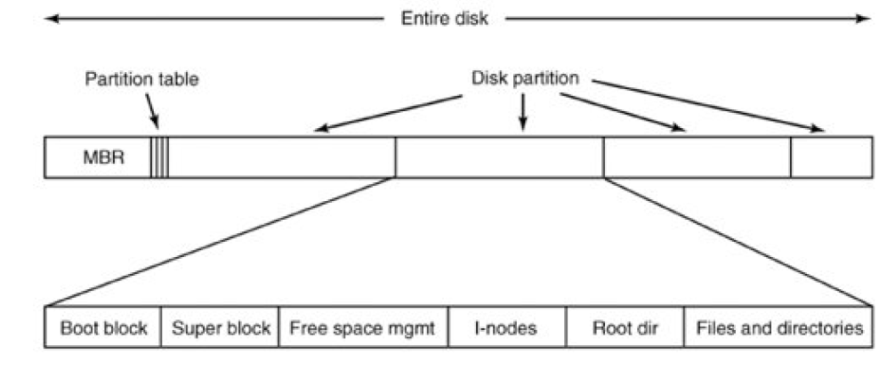

Implementing Files
The most important issue in implementing file storage is keeping track of which disk
blocks go with which file. Various methods are used in different operating systems.
- Contiguous Allocation
- The simplest allocation scheme is to store each file as a contiguous run of disk blocks.
- Contiguous disk space allocation has two significant advantages.
- First, it is simple to implement because keeping track of where a file's blocks are is reduced to remembering two numbers: the disk address of the first block and the number of blocks in the file
- Second, the read performance is excellent because the entire file can be read from the disk in a single operation
- The major drawback of Contiguous Allocation
- in time, the disk becomes fragmented, consisting of files and holes.
- External fragmentation is a major issue with this type of allocation technique.
- Linked Allocation
- The first word of each block is used as a pointer to the next one. The rest of the block is for data.
- No space is lost to disk fragmentation
- it is sufficient for the directory entry to merely store the disk address of the first block
- reading a file sequentially is straightforward, random access is extremely slow.
- To get to block n, the operating system has to start at the beginning and read the n 1 blocks prior to it, one at a time.
Storing a file as a linked list of disk blocks.
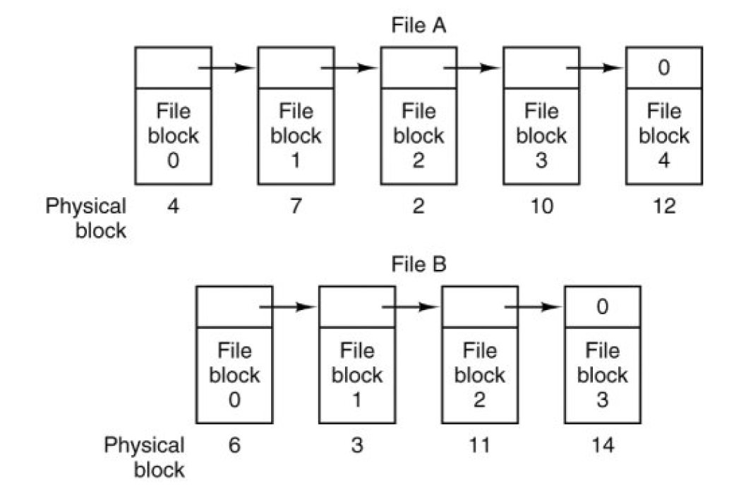
- Indexed Allocation
- Provides solutions to problems of contiguous and linked allocation by taking the pointer word from each disk block and putting it in a table in memory.
- Each file has its own index block which stores the addresses of disk space occupied by the file. File A uses disk blocks 4, 7, 2, 10 and 12, in that order, and file B uses disk blocks 6, 3, 11, and 14, in that order.
- Using the table, we can start with block 4 and follow the chain all the way to the end. The same can be done starting with block 6.
Linked list allocation using a file allocation table in main memory
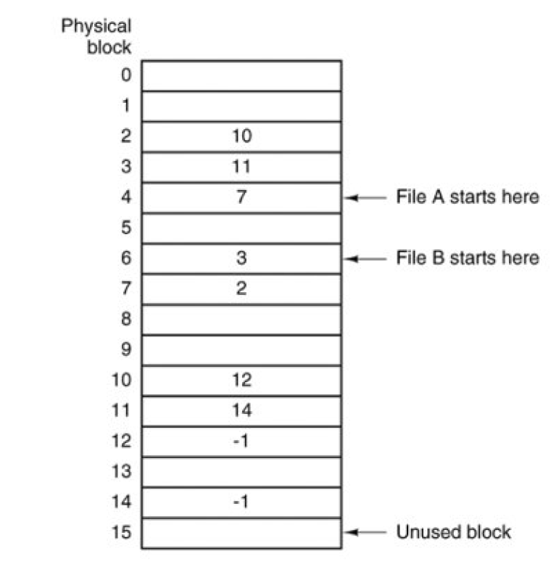
- Using this organization, the entire block is available for data
- random access is much easier.
- The primary disadvantage of this method is that the entire table must be in memory all the time.
- I-Nodes(index-nodes)
lists the attributes and disk addresses of the file's blocks
The big advantage of this scheme over linked files using i-node need only be in memory when the corresponding file is open.
File Allocation Table (FAT)
Microsoft created the File Allocation Table file system and is the simplest file system supported by Windows NT. It is the older of the two file systems and therefore isn’t as efficient or advanced. However, it does offer more compatibility with other operating systems and removable storage devices.
NTFS(New Technology file system)
It was introduced as a replacement for the FAT file system, designed to improve upon FAT by increasing performance, reliability and disk space. NTFS supports:
- Very large files
- Different file permissions and encryption
- Automatically restores consistency by using log file and checkpoint information
- File compression when running out of disk space
.

BACKUP STRATEGIES:

Backing up of files can be done on modern tapes.

Modern tapes hold tens or sometimes even hundreds of gigabytes

Backups are done to:

1. Recover from disaster – accidents like disk crash, fire, flood or some natural catastrophe

2. Recover from stupidity – accidentally removing files.

Few issues in backing up data’s are:

Should the data’s be compressed to save some space before backing up is made

How should the backup on active file system has to be made.

Will backing up lead to non technical problems like security problems related to data’s

Operating System Security
Security refers to providing a protection system to computer system resources such as CPU, memory, disk, software programs and most importantly data/information stored in the computer system. If a computer program is run by unauthorized user then he/she may cause severe damage to computer or data stored in it. So a computer system must be protected against unauthorized access, malicious access to system memory, viruses, worms etc.
The Security Problem
The operating system can allow users to protect their resources. We say that a system is secure if its resources are used and accessed as intended under all circumstances. Unfortunately, it is not generally possible to achieve total security. Security violations of the system can be categorized as being either intentional (malicious) or accidental.
Authentication
Authentication refers to identifying each user of the system and associating the executing programs with those users. It is the responsibility of the Operating System to create a protection system which ensures that a user who is running a particular program is authentic. Operating Systems generally identifies/authenticates users using following three ways:
- Username / Password - User need to enter a registered username and password with Operating system to login into the system.
- User card/key - User need to punch card in card slot, or enter key generated by key generator in option provided by operating system to login into the system.
- User attribute - fingerprint/ eye retina pattern/ signature - User need to pass his/her attribute via designated input device used by operating system to login into the system.
One Time passwords
One time passwords provides additional security along with normal authentication. In One-Time Password system, a unique password is required every time user tries to login into the system. Once a one-time password is used then it cannot be used again. One time password are implemented in various ways.
- Random numbers - Users are provided cards having numbers printed along with corresponding alphabets. System asks for numbers corresponding to a few alphabets randomly chosen.
- Secret key - User are provided a hardware device which can create a secret id mapped with user id. System asks for such secret id which is to be generated every time prior to login.
- Network password - Some commercial applications send one time password to user on registered mobile/ email which is required to be entered prior to login.
Program Threats
Operating system's processes and kernel do the designated task as instructed. If a user program made these process do malicious tasks then it is known as Program Threats. One of the common examples of program threat is a program installed in a computer which can store and send user credentials via network to some hacker. Following is the list of some well-known program threats.
- Trojan horse - Such program traps user login credentials and stores them to send to malicious user who can later on login to computer and can access system resources.
- Trap Door - If a program which is designed to work as required, have a security hole in its code and perform illegal action without knowledge of user then it is called to have a trap door.
- Logic Bomb - Logic bomb is a situation when a program misbehaves only when certain conditions met otherwise it works as a genuine program. It is harder to detect.
- Virus - Virus as name suggests can replicate them on computer system .They are highly dangerous and can modify/delete user files, crash systems. A virus is generally a small code embedded in a program.
System Threats
System threats refer to misuse of system services and network connections to put user in trouble. System threats create such an environment that operating system resources/ user files are mis-used. Following is the list of some well-known system threats.
- Worm -Worm is a process which can choke down a system performance by using system resources to extreme levels. A Worm process generates its multiple copies where each copy uses system resources, prevents all other processes to get required resources. Worm processes can even shut down an entire network.
- Port Scanning - Port scanning is a mechanism or means by which a hacker can detects system vulnerabilities to make an attack on the system.
- Denial of Service - Denial of service attacks normally prevents user to make legitimate use of the system. For example user may not be able to use internet if denial of service attacks browser's content settings.

